Reflection and Prayer: The picture on the front cover of todays notices is of a deer that I spotted in Mytchett. It had somehow found itself by the railway line trapped on the bank. Sadly it had a graze down one side, but otherwise seemed in good health. One of my favourite hymns is a reflection on this Psalm, comparing a deer longing for water as we long for for God. Sometimes we find ourselves wishing everything was different, wanting things to change so that we can ‘feel better’ or more satisfied with life, longing for something else. This feeling of yearning and desire is planted by God in us, to wake us up to find peace in him, to have hope in him as the Psalmist says. May I encourage you to pray for this inner peace, that our longing may be satified inJesus Christ your saviour.
Dear Father in heaven, Thank you for the encouragment of this Psalm, that in every generation you can speak to our hearts, especially when they are longing to be reassured. Help us to drink at the stream of your love that we may be filled, our thirst quenched by your Holy Spirit. Give us a clearer understanding of who you are and what you want us to do in our daily lives. We pray this in Jesus name, Amen RG

Items for Church Notices
Items to be included in the Church Notices for w/c Sunday 28th June 2020, to reach K. Gilchrist by 7.00 pm on Thursday 25th June 2020.
Please contact her by email: khgilchrist@hotmail.co.uk or phone 01252 378679

Contacts
Minister Revd G. Hoff 01252 517045
Senior Steward Gill 01276 516085
Prayer Chain M. Edwards 01252 548739
Tuesday @ 2 C. Trufitt 01252 514748
Church Walks T. Hocking 01252 875158
Room Hire Andrea
covemethodist65@gmail.com
Guides, Brownies & Rainbows Michelle farnborough.division@outlook.com

Good news!! Alicia has been working on the website! https://www.covemethodist-farnborough.co.uk

Cove Methodist Church

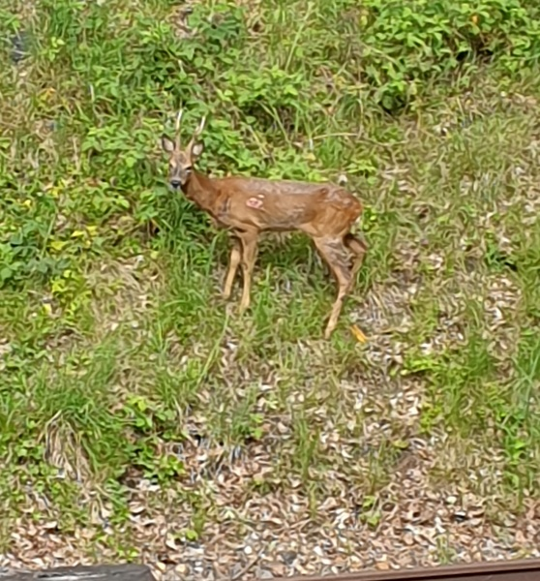
Psalm 42: 1-5 As the deer pants for water, so I long for you, O God. I thirst for God, the living God. Where can I find him to come and stand before him? Day and night I weep for his help, and all the while my enemies taunt me. “Where is this God of yours?” they scoff. Take courage, my soul! Do you remember those times (but how could you ever forget them!) when you led a great procession to the Temple on festival days, singing with joy, praising the Lord? Why then be downcast? Why be discouraged and sad? Hope in God! I shall yet praise him again. Yes, I shall again praise him for his help. RG Check out the reflection to go with these verses.

A warm welcome to everyone

These notices come to you with our very best wishes from everyone at Cove Methodist Church.
If you have any prayers, thoughts or poems which would brighten someone’s day please them forward to us and we will try and include them to share here or online.
We hope you are all finding the notices and the weekly services helpful.
‘We will rejoice in Christ when we meet again.’

SUNDAY 21ST JUNE 2020 LIVE BROADCAST
Revd Billy Slatter the Minister at Fleet Methodist Church is offering a broadcast service at 10.30 am
facebook.com/fleetmethodistservices

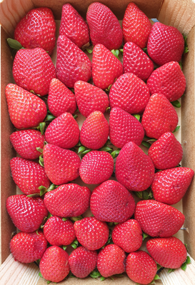
June for many is month for strawberries, tennis and Summer Solstice. Often the way we live these days is detached from the natural world, we buy bread wrapped in a plastic bag and clean vegetables and other packaged food from supermarkets. We clean our teeth with a paste that comes out of a tube and our clothes although often made from plant fibres, bear no resemblance to the raw materials they contain. Were it not for walks in the country, gardening, and so on, often the only way we might experience the natural world is through our televisions, perhaps ‘Springwatch’ and ‘Gardeners World’. Lots of us are much more connected to nature than this, but you get my drift. The word ‘solstice’ is a compound of two Latin words, ‘sol’ meaning ‘sun’ and ‘sistere’ meaning to ‘stand’ or ‘halt’. It’s a time when the sun seems to stand still, to hang in the heavens for a time. And it’s a time when humans can be still too – to take time to be thankful for the world we live in. To be thankful for the fruitfulness of the earth, it is likely that all life comes from the sun – plants have life because of photosynthesis and produce delicious fruit such as strawberries, creatures have life because they consume plants, or consume creatures that consume plants. More or less all life is viable only because of the sun created by God as a light in the sky for all life on earth. So this weekend, enjoy the fullness of the sun, a gift from the creator to us. P.S The picture is of our breakfast strawberries, tennis anyone? RG

For those of you who are interested this are the Government guidelines for reopening church buildings
https://www.gov.uk/government/publications/covid-19-guidance-for-the-safe-use-of-places-of-worship-during-the-pandemic/covid-19-guidance-for-the-safe-use-of-places-of-worship-during-the-pandemic?fbclid=IwAR3VMcZydXW_D2alBUlGhPoX4ow2og6fYQQOwtY3qWc4ocsahJ2fdtArFic

FAMILY PRAYER During this time of uncertainty, please remember all those within the Church Family in your prayers who are unwell, waiting news of treatment or results, those continuing on the road to recovery and those who are facing challenges in their lives, along with those are having to be isolated from family and friends. We also think of those in Care Homes, Hospices or relying on carers at this time, along with their families, at this time of uncertainty, with being unable to control their lives in the same way.
We remember Peggy, who sadly died on 5th June in a nursing home in Alton. We pray for Wally and the family at this time. Peggy’s funeral will take place this coming Thursday morning, 25th June at 11.00 am. We also keep Christine and Jim in our prayers after the recent death of Christine’s mother Lillian.
Please remember any members of our Church Family and their families in your prayers, who are showing the signs of the Coronavirus.
Any Prayer Requests, please contact Revd Gina or Ann S who will pass information to the Prayer Chain.

Alternative services For those people who are not on ‘Facebook’, there is ‘Sunday Worship’ on BBC1 at 10.45 am and there is also a service on Radio 4 at 8.10 am on Sunday morning. Then at 1.15 pm there is ‘Songs of Praise’ on BBC1. The Methodist website has a Bible reading and a daily prayer for those of you online. Alton Methodist Church website has a morning service.
Methodist Church Website You can find the regular updates on the Methodist Church website of interest and useful https://www.methodist.org.uk You may enjoy having a look at what’s happening in Connexion too.
Used ‘Lockdown’ for a good clear out?
Many of you will have taken the opportunity to have a good sort out of cupboards during the last few weeks. If you have things that may be sold at our next Table Top Sale, please box or bag them up and hang on to them!! When things get back to some sort of normal, we will have a sale and top up church funds or put money towards our Growth Plan. If you can’t wait to get rid of stuff, get in contact and I’ll try and take it for you.
Don’t forget to collect ink cartridges and Bob Hatten is also looking to recycle metals – all for church funds.

A Reminder of the Bank Details
If you would like to set up a standing order for your offering or give a gift to the church, please use the following details to set one up:
Acc. Name: Cove Methodist Church
Acc. Number: 01604511 Sort code: 30-90-09

